ORDER OF WORSHIP
* Indicates, please stand if able.
Sixth Sunday after Pentecost July 17, 2022. 9:00am
Liturgist: Chuck Devendorf

WELCOME, PASSING THE PEACE OF CHRIST, & ANNOUNCEMENTS
*CALL TO WORSHIP
L: We gather this day from a week filled with needs and demands
P: We come to find rest and renewal of our spirits.
L: Open your hearts in love to hear the voice of God.
P: We want to quietly rest in God’s presence, free from the clamor of the world.
L: This is the day that the Lord has made.
P: Let us rejoice and be glad in it. AMEN.
*OPENING PRAYER
Glorious name, gracious name, name of love and of power! Through you sins are forgiven; through you enemies are vanquished; through you the sick are freed from their illness; through you those suffering in trials are made strong and cheerful. You bring honor to those who believe, you teach those who preach, you give strength to the toiler, you sustain the weary.
- St. Bernardine of Siena, 1380 – 1444
*OPENING HYMN “My Life is in You Lord” # 2032
CHILDREN’S TIME Katrina McGillivray
JOYS AND CONCERNS

PRAYER OF CONFESSION
Patient Lord, we schedule our lives down to the very second. We crowd in as much activity as we can and then wonder why we are so stressed out and tired. We are afraid to miss out on anything. And when it comes time to be with others we spend our time worrying about details rather than longing for the visit. Forgive us when we get so caught up in the details and miss the opportunity to sit at your feet, learning, listening and growing in our faith. Help us to place ourselves in your care. Slow us down, just a bit, so that we can see the wonders you have placed before us and truly enjoy and share the blessings you have given to us. For we ask these things in Jesus’ name. AMEN

WORDS OF ASSURANCE
On the seventh day of creation, God rested, creating a Sabbath, a time set apart for rest, to learn, to listen, to be quiet and at peace. Let Sabbath take root in your heart and in your life. Be at peace in God’s love for you. AMEN.
PASTORAL PRAYER
THE LORD’S PRAYER (In Unison)
Our Father, who art in heaven, hallowed be thy name. Thy kingdom come, thy will be done on earth as it is in heaven. Give us this day our daily bread. And forgive us our trespasses, as we forgive those who trespass against us. And lead us not into temptation, but deliver us from evil. For thine is the kingdom, and the power, and the glory, forever. Amen.
BRINGING OUR GIFTS TO GOD WITH GRATEFUL HEARTS
As Amos observed long ago, in our world the poor are too often sold for silver and the needy for a pair of sandals. But we can live a different ethic—our lives can embody the love of God. Let’s make room for others through our giving, that they may also know God’s love and hope.
*DOXOLOGY “Praise God, from Whom All Blessings Flow” #95
*OFFERTORY PRAYER
SCRIPTURE Psalm 23:1-6
*HYMN OF PRAISE “Give Thanks with a Grateful Heart” #2152
MESSAGE “I Shall Not Want” Rev. Shon
*CLOSING HYMN “Cry of My Heart” # 2165

*BENEDICTION Rev. Shon

POSTLUDE

Bible Verse Today: Psalm 23:1-2
“The Lord is my shepherd, I shall not want. He makes me lie down in green pastures.”

SCRIPTURE: Psalm 23:1-6 (NIV)
The Lord is my shepherd, I lack nothing. ² He makes me lie down in green pastures, he leads me beside quiet waters, ³ he refreshes my soul. He guides me along the right paths for his name’s sake. ⁴ Even though I walk through the darkest valley, I will fear no evil, for you are with me; your rod and your staff, they comfort me. ⁵ You prepare a table before me in the presence of my enemies. You anoint my head with oil; my cup overflows. ⁶ Surely your goodness and love will follow me all the days of my life, and I will dwell in the house of the Lord forever.

ANNOUNCEMENTS:
RADIO BROADCAST: The Radio Broadcast this morning is in honor of Daniel Brauner’s 67th Birthday sponsored by Jocelyn Brauner.
PRAYER FAMILIES: Pray for all those who need healing, or have health issues. Specifically, pray for Karen Dolsey, Madyson Schultz, Nancy Iuliano, Edward Brauner and Stanly Demotts who has prostate cancer. Also continue to pray for those in Ukraine and other areas of the world who are suffering, and pray that mass shootings will soon come to an end.
SCRIP CARDS: When you are thinking of ideas for gift giving or personal use, consider Scrip
cards. Stop at the gathering area on Sundays or call Marcia at 715-284-3346 and see if we can
help.
PATRICIA PROJECT: The Patricia Project Sewing Day will be July 26, from 1pm to 3pm. All sewers are needed but especially those with sergers. Contact Charlene Galston for more information by calling 715 284 9544 or texting 715 896 9055.
STAINED GLASS WINDOW: Recently, the Stained Glass Window was inspected for the first time in 28 years. Willet Hauser, Architectural Glass, discovered there were some broken, cracked or missing pieces plus some glass is out of the original lead channel. The cost to repair our window is $4,109. If you would like to contribute to the repair of the stained glass window, please note on either your check or envelope. Thank you for helping keep the church building and its various parts in good working order.
USHERS/GREETERS: Judy & Mari Sheppard

THIS WEEK AT THE CHURCH: Wednesday: Prayer Meeting 10:00am

Black River Falls
United Methodist Church

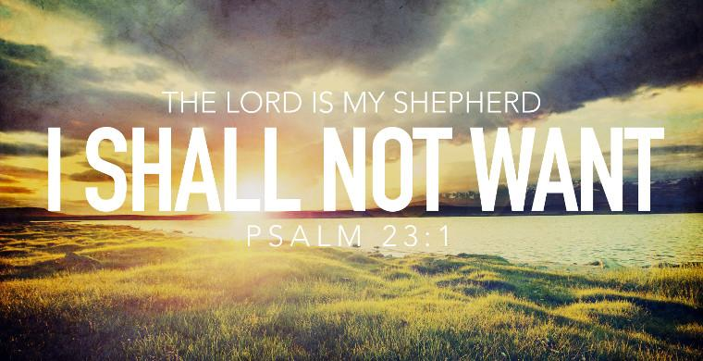

`Mission statement:
"To make disciples of Jesus Christ for the transformation of the world by proclaiming
the good news of God's grace and by exemplifying Jesus' command to love God and
neighbor, thus seeking the fulfillment of God's reign and realm in the world."

PASTOR Rev. Inwha Shon
ORGANIST Matthew Schluntz
MUSIC DIRECTOR Amanda Lang

100 North Fourth Street, Black River Falls, WI. 54615
Phone: 715-284-4114 Office Hours:8 am - 4 pm
Website: brfumc.org & Black River Falls United Methodist Church Facebook

